

Eduvos Assessment Coversheet
Academic Details
Campus: | Online Campus
Faculty: | BSc IT
Module Code: | ITBDA4-14
Lecturer’s Name: | Mr. Lekula. G.
Group (if applicable)
Assessment Details
Assessment Type: | Project
Assignment/Brief Number: | 2
Due Date/ Submission Date: | 2026/11/13
Student Details (Group, if applicable)
# | Full Name | Student Number | Contact Number | % Participation | Signature
1
2
3
Student Details (Individual, if applicable)
Student Full Name: | Lodewikus Joubert
Student Number: | EDUV4818544
Academic Integrity
AI Disclosure Completed | Yes  x | No
Declaration:
I declare that this assessment is my own original work except for source material explicitly acknowledged. I confirm that this work has not previously been submitted for assessments in any course. I acknowledge the institutional AI policy and confirm that AI tools have only been used as stipulated and documented in the AI Disclosure Appendix.

Student Signature | 
Date | 2026/11/08
Lecturer Use Only
Lecturer Comments:
Marks Awarded (%):
Lecturer Signature:
Date:
Question 1.1
I will use the MapReduce process to search the supplied text documents for a keyword and return its row and column positions. First, I will place the 17 documents in the input directory and use an R preparation script to add the filename and original row number to every line. The keyword will be entered dynamically by the user instead of being hardcoded. The Mapper will read each prepared record and perform a case-insensitive, whole-word search for the keyword. For every match, it will produce the document name together with the row and starting column number. When Hadoop Streaming is used, the shuffle and sort stage will group all matches belonging to the same document before passing them to the Reducer. Finally, the Reducer will arrange the positions in order and produce a text file showing the locations of each matching keyword.

Logical layout diagram:
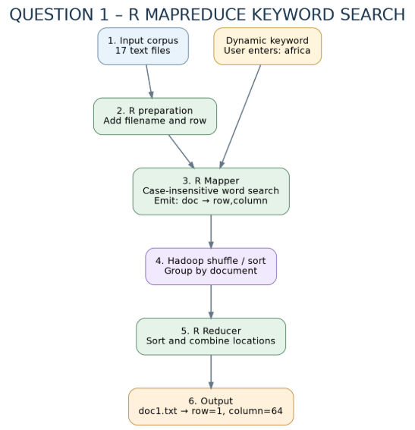

Script: 01_prepare_input.R
# Question 1.1 - Prepare input documents for MapReduce
# 01_prepare_input.R
# Prepare the documents for MapReduce.

prepare_input <- function(
input_dir = "Question_1_MapReduce/input",
prepared_dir = "Question_1_MapReduce/prepared"
) {

files <- sort(list.files(
input_dir,
pattern = "\\.txt$",
full.names = TRUE
))

if (length(files) == 0) {
stop("No text files found in the input folder.")
}

dir.create(prepared_dir,
recursive = TRUE,
showWarnings = FALSE)

for (file in files) {

lines <- readLines(
file,
warn = FALSE,
encoding = "UTF-8"
)

records <- paste(
basename(file),
seq_along(lines),
lines,
sep = "\t"
)

writeLines(
records,
file.path(prepared_dir, basename(file)),
useBytes = TRUE
)
}

cat("Prepared", length(files), "documents.\n")

invisible(length(files))
}

Question 1.2
I implemented the Mapper in R using the map_records() function. The Mapper receives prepared records containing a document name, row number and text, together with a dynamically entered keyword. It converts both the keyword and the text to lowercase before searching, which makes the search case-insensitive. The gregexpr() function identifies the starting positions of any matching text within each line. I check the characters immediately before and after each occurrence to avoid treating parts of longer words, such as “African”, as matches for “africa”. Each accepted match is emitted in the form document name, row number and column number. The Mapper can also read records from standard input when Hadoop Streaming runs the script, allowing the same R function to be used for both local testing and Hadoop execution.

Script: 02_mapper.R
# Question 1.2 - R Mapper implementation
# 02_mapper.R
# Search for keyword matches and return their locations.

map_records <- function(records, keyword) {

if (length(keyword) != 1 ||
!nzchar(trimws(keyword))) {
stop("Please provide a keyword.")
}

output <- character()
keyword_length <- nchar(keyword, type = "chars")

for (record in records) {

parts <- strsplit(
record, "\t", fixed = TRUE
)[[1]]

if (length(parts) < 3) next

document <- parts[1]
row <- parts[2]
line <- paste(parts[-c(1, 2)], collapse = "\t")

positions <- gregexpr(
tolower(keyword),
tolower(line),
fixed = TRUE
)[[1]]

if (positions[1] == -1) next

for (column in positions) {

before <- if (column > 1) {
substr(line, column - 1, column - 1)
} else {
""
}

after_pos <- column + keyword_length

after <- if (
after_pos <= nchar(line, type = "chars")
) {
substr(line, after_pos, after_pos)
} else {
""
}

is_word <- function(char) {
nzchar(char) &&
grepl("^[[:alnum:]_]$", char)
}

if (!is_word(before) && !is_word(after)) {

output <- c(
output,
paste(
document,
paste(row, column, sep = ","),
sep = "\t"
)
)
}
}
}

output
}

# Read input records when executed by Hadoop Streaming.

if (sys.nframe() == 0) {

keyword <- Sys.getenv("SEARCH_KEYWORD")

if (!nzchar(trimws(keyword))) {
stop("SEARCH_KEYWORD is required.")
}

connection <- file("stdin", "r")

repeat {

record <- readLines(
connection,
n = 1,
warn = FALSE
)

if (length(record) == 0) break

result <- map_records(record, keyword)

if (length(result)) {
cat(
paste(result, collapse = "\n"),
"\n",
sep = ""
)
}
}

close(connection)
}

Question 1.3
I implemented the Reducer in R using the reduce_records() function. It reads the Mapper output and groups matching positions by document name. It separates the row and column coordinates and converts them into numbers so that they can be sorted correctly. Each document’s positions are ordered first by row number and then by column number. The Reducer combines these positions into a readable result showing every match for each document. When Hadoop Streaming runs the script, it receives the records in document-key order and writes the reduced output to standard output.

Script: 03_reducer.R
# Question 1.3 - R Reducer implementation
# 03_reducer.R
# Group and sort keyword locations.

reduce_records <- function(records) {

if (length(records) == 0) {
return(character())
}

document <- sub("\t.*$", "", records)

location <- sub(
"^[^\t]*\t", "", records
)

groups <- split(
seq_along(records),
document
)

output <- character()

for (name in names(groups)) {

positions <- strsplit(
location[groups[[name]]],
",",
fixed = TRUE
)

rows <- as.integer(
vapply(positions, `[`, character(1), 1)
)

columns <- as.integer(
vapply(positions, `[`, character(1), 2)
)

order_by_position <- order(rows, columns)

coordinates <- paste0(
"row=", rows[order_by_position],
", column=", columns[order_by_position]
)

output <- c(
output,
paste(
name,
paste(coordinates, collapse = "; "),
sep = "\t"
)
)
}

output
}

# Read grouped Mapper results in Hadoop Streaming.

if (sys.nframe() == 0) {

connection <- file("stdin", "r")

current_document <- ""
group <- character()

repeat {

record <- readLines(
connection,
n = 1,
warn = FALSE
)

if (length(record) == 0) break

document <- sub("\t.*$", "", record)

if (length(group) > 0 &&
document != current_document) {

cat(reduce_records(group), "\n", sep = "")
group <- character()
}

current_document <- document
group <- c(group, record)
}

if (length(group) > 0) {
cat(reduce_records(group), "\n", sep = "")
}

close(connection)
}

Question 1.4
I configured the Hadoop MapReduce job using an R script and Hadoop Streaming, which supports R scripts as the Mapper and Reducer. The configuration identifies the prepared input directory, the two R processing scripts and the output directory. It supplies the keyword dynamically through the SEARCH_KEYWORD environment variable and sets Hadoop to use local execution mode with one Reducer. The job runs the Mapper, performs Hadoop’s shuffle and sort stage, and passes the grouped records to the Reducer. I also created a separate local RStudio script for testing the same logic and saving the results without starting Hadoop. The local test has returned 17 documents checked, 7 matching documents and 28 whole-word matches for “africa”; this confirms the R logic but is not evidence that a Hadoop job has been executed.

Script: 05_run_hadoop.R
# Question 1.4 - Hadoop MapReduce configuration in R
# 05_run_hadoop.R
# Configure and execute Hadoop Streaming using R.

args <- commandArgs(trailingOnly = TRUE)

if (length(args) == 0) {
stop("Please supply a search keyword.")
}

keyword <- paste(args, collapse = " ")

if (.Platform$OS.type == "windows") {
stop("Run this in Ubuntu/WSL with Hadoop installed.")
}

# Prepare documents.

source("Question_1_MapReduce/R/01_prepare_input.R")
prepare_input()

# Locate Hadoop.

hadoop_home <- Sys.getenv("HADOOP_HOME")

if (!nzchar(hadoop_home)) {
stop("HADOOP_HOME is not configured.")
}

streaming_dir <- file.path(
hadoop_home, "share", "hadoop", "tools", "lib"
)

jars <- list.files(
streaming_dir,
pattern = "^hadoop-streaming-[0-9].*\\.jar$",
full.names = TRUE
)

if (length(jars) == 0) {
stop("Hadoop Streaming JAR not found.")
}

# Configure input and output paths.

input_dir <- normalizePath(
"Question_1_MapReduce/prepared"
)

mapper <- normalizePath(
"Question_1_MapReduce/R/02_mapper.R"
)

reducer <- normalizePath(
"Question_1_MapReduce/R/03_reducer.R"
)

safe_keyword <- gsub(
"[^A-Za-z0-9_-]", "_", keyword
)

dir.create(
"Question_1_MapReduce/output",
showWarnings = FALSE
)

output_dir <- file.path(
normalizePath("Question_1_MapReduce/output"),
paste0("hadoop_", safe_keyword)
)

if (dir.exists(output_dir)) {
stop("Hadoop output already exists: ", output_dir)
}

# Hadoop MapReduce settings.

job_args <- c(
"jar", shQuote(jars[1]),

"-D", "mapreduce.framework.name=local",
"-D", "fs.defaultFS=file:///",
"-D", "mapreduce.job.reduces=1",

"-files",
shQuote(paste(mapper, reducer, sep = ",")),

"-input", shQuote(input_dir),
"-output", shQuote(output_dir),

"-mapper", shQuote("Rscript 02_mapper.R"),
"-reducer", shQuote("Rscript 03_reducer.R"),

"-cmdenv",
shQuote(paste0("SEARCH_KEYWORD=", keyword))
)

# Execute the Hadoop job.

hadoop <- file.path(
hadoop_home, "bin", "hadoop"
)

status <- system2(
hadoop,
args = job_args
)

if (!identical(status, 0L)) {
stop("Hadoop job failed. Exit code: ", status)
}

# Display the results.

part_files <- list.files(
output_dir,
pattern = "^part-",
full.names = TRUE
)

if (length(part_files) == 0) {
stop("Hadoop output file was not found.")
}

cat("\nHadoop job completed.\n")

cat(
paste(
readLines(part_files[1], warn = FALSE),
collapse = "\n"
),
"\n",
sep = ""
)

Local demonstration:
Script: 04_run_local.R
# Question 1 - Local MapReduce demonstration in RStudio
# 04_run_local.R
# Run the MapReduce process locally in RStudio.

# Load required scripts.
source("Question_1_MapReduce/R/01_prepare_input.R")
source("Question_1_MapReduce/R/02_mapper.R")
source("Question_1_MapReduce/R/03_reducer.R")

# Ask the user to enter a keyword.
keyword <- utils::winDialogString(
"Enter keyword to search:",
default = ""
)

# Validate the keyword.
if (is.null(keyword) || !nzchar(trimws(keyword))) {
stop("The keyword cannot be empty.")
}

keyword <- trimws(keyword)

cat("\nSearching for keyword:", keyword, "\n")

# Prepare the input documents.
prepare_input()

# Get all prepared text files.
files <- sort(list.files(
"Question_1_MapReduce/prepared",
pattern = "\\.txt$",
full.names = TRUE
))

# Run the Mapper.
mapped <- unlist(lapply(files, function(file) {

map_records(
readLines(
file,
warn = FALSE,
encoding = "UTF-8"
),
keyword
)

}), use.names = FALSE)

# Run the Reducer.
reduced <- reduce_records(mapped)

# Create output directory.
output_dir <- "Question_1_MapReduce/output"

dir.create(
output_dir,
showWarnings = FALSE
)

# Create output filename based on keyword.
safe_keyword <- gsub(
"[^A-Za-z0-9_-]",
"_",
keyword
)

output_file <- file.path(
output_dir,
paste0("local_", safe_keyword, ".txt")
)

# Save the results.
writeLines(
reduced,
output_file,
useBytes = TRUE
)

# Display the results.
cat("\nDocuments checked:", length(files), "\n")
cat("Matching documents:", length(reduced), "\n")
cat("Total matches:", length(mapped), "\n\n")

cat("RESULTS (document, row, column):\n")

if (length(reduced) > 0) {
cat(paste(reduced, collapse = "\n"), "\n")
} else {
cat("No matches found.\n")
}

cat("\nSaved results to:", output_file, "\n")

Output:
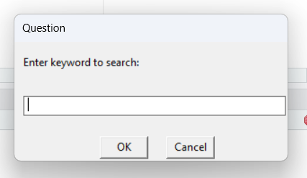
Output:
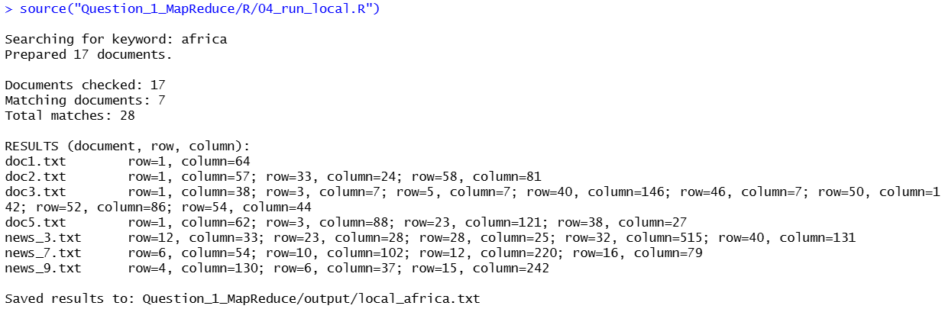

Question 2.1
I loaded the ten supplied news text files into R and created a data frame with the two required columns, file_name and content. Each row stores the original filename and the complete text of one article, and all ten documents were loaded without missing content. I cleaned the documents by converting text to lowercase, transliterating special characters and removing URLs, numbers, punctuation, short words, English stop words and selected reporting terms. This reduced the combined whitespace-separated word count from 3,832 in the original articles to 2,199 in the cleaned text, while keeping all ten documents. I saved both news_raw.csv and news_cleaned.csv to preserve the originals and provide suitable text for LDA topic modelling.

Script: 01_load_preprocess.R
# Question 2.1 - Load and preprocess news documents
# 01_load_preprocess.R

# Load the 10 news files into a data frame.
load_news <- function() {

input_dir <- "Question_2_Topic_Modeling/input"

files <- sort(list.files(
input_dir,
pattern = "\\.txt$",
full.names = TRUE
))

if (length(files) != 10) {
stop("Exactly 10 news files are required.")
}

news_df <- data.frame(
file_name = basename(files),
content = vapply(files, function(file) {
paste(
readLines(
file,
warn = FALSE,
encoding = "UTF-8"
),
collapse = " "
)
}, character(1)),
stringsAsFactors = FALSE
)

rownames(news_df) <- NULL

return(news_df)
}

# Clean the text in each document.
clean_text <- function(text) {

# Convert accented and special characters.
text <- iconv(
text,
from = "UTF-8",
to = "ASCII//TRANSLIT",
sub = " "
)

# Convert to lowercase.
text <- tolower(text)

# Remove website links.
text <- gsub(
"https?://[^[:space:]]+|www\\.[^[:space:]]+",
" ",
text
)

# Remove numbers and punctuation.
text <- gsub("[^a-z[:space:]]", " ", text)

# Split text into individual words.
words <- strsplit(
text,
"[[:space:]]+"
)[[1]]

# Remove very short words.
words <- words[nchar(words) >= 3]

# Remove common English stop words.
words <- words[
!words %in% tm::stopwords("en")
]

# Remove unnecessary reporting words.
noise_words <- c(
"said", "says", "would", "could",
"also", "read", "gov", "according"
)

words <- words[
!words %in% noise_words
]

# Rebuild the cleaned text.
return(paste(words, collapse = " "))
}

# Preprocess the full news data frame.
preprocess_news <- function(news_df) {

cleaned_df <- data.frame(
file_name = news_df$file_name,
content = vapply(
news_df$content,
clean_text,
character(1)
),
stringsAsFactors = FALSE
)

return(cleaned_df)
}

Output:
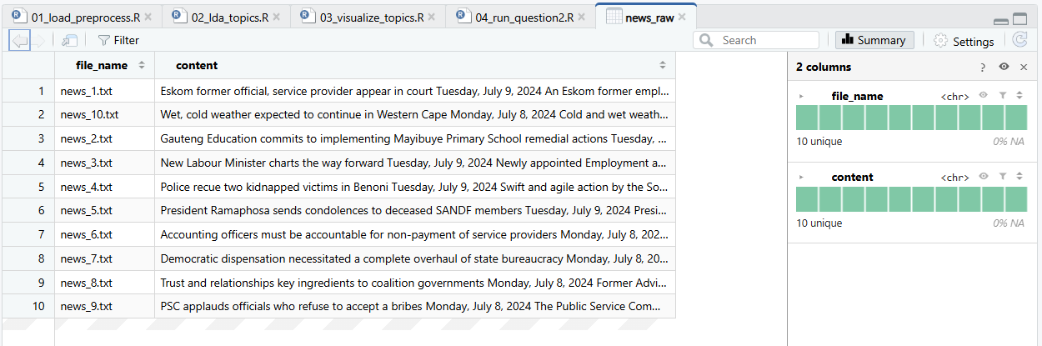
Output:
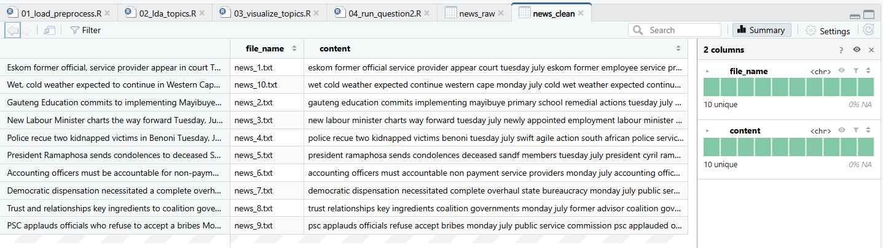
Question 2.2
I used Latent Dirichlet Allocation (LDA) to identify patterns in the ten cleaned news articles. I converted the cleaned text into a document-term matrix containing 1,109 distinct words. I fitted three topics using Gibbs sampling with a fixed seed of 1234 and extracted the eight highest-probability words for each topic. Topic 1 was led by service (0.0248), invoices (0.0201) and psc (0.0142), suggesting a focus on public services and administrative matters. Topic 2 was led by department (0.0290), public (0.0278) and south (0.0194), indicating government departments and public institutions. Topic 3 was led by government (0.0225), coalition (0.0155) and country (0.0107), indicating government coalitions and broader public affairs. The average topic probabilities across the ten documents were 38.24% for Topic 1, 33.36% for Topic 2 and 28.40% for Topic 3. I also saved the complete word-probability distributions and each document's topic probabilities, including strong Topic 1 association for news_6.txt (77.74%) and Topic 3 association for news_8.txt (78.83%). Because this is a small and mixed news collection, the topic labels are interpretations of the model results rather than definitive categories for every article.

Script: 02_lda_topics.R
# Question 2.2 - LDA topic modelling
# 02_lda_topics.R

fit_lda_model <- function(
cleaned_df,
n_topics = 3,
top_k = 8) {

# Create a corpus from the cleaned documents.
corpus <- tm::VCorpus(
tm::VectorSource(cleaned_df$content)
)

# Create a document-term matrix.
dtm <- tm::DocumentTermMatrix(
corpus,
control = list(wordLengths = c(3, Inf))
)

# Check that all documents contain words.
if (any(rowSums(as.matrix(dtm)) == 0)) {
stop("One or more documents are empty.")
}

if (n_topics > nrow(dtm)) {
stop("Too many topics for the documents.")
}

# Train the LDA model using Gibbs sampling.
lda_model <- topicmodels::LDA(
dtm,
k = n_topics,
method = "Gibbs",
control = list(
seed = 1234,
burnin = 500,
iter = 1000,
thin = 100
)
)

# Extract topic and word probabilities.
probabilities <- topicmodels::posterior(
lda_model
)

word_probs <- probabilities$terms
document_probs <- probabilities$topics

topic_names <- paste(
"Topic", seq_len(n_topics)
)

# Identify the top k words for each topic.
top_words <- do.call(
rbind,
lapply(seq_len(n_topics), function(i) {

positions <- order(
word_probs[i, ],
decreasing = TRUE
)[seq_len(min(top_k, ncol(word_probs)))]

data.frame(
topic = topic_names[i],
rank = seq_along(positions),
word = colnames(word_probs)[positions],
probability = as.numeric(
word_probs[i, positions]
),
stringsAsFactors = FALSE
)
})
)

# Store the full word distribution per topic.
word_distribution <- do.call(
rbind,
lapply(seq_len(n_topics), function(i) {

data.frame(
topic = topic_names[i],
word = colnames(word_probs),
probability = as.numeric(word_probs[i, ]),
stringsAsFactors = FALSE
)
})
)

# Store topic probabilities for each document.
document_topics <- data.frame(
file_name = cleaned_df$file_name,
as.data.frame(document_probs),
check.names = FALSE
)

colnames(document_topics) <- c(
"file_name", topic_names
)

# Calculate average topic prevalence.
topic_prevalence <- data.frame(
topic = topic_names,
average_probability = colMeans(
document_probs
)
)

# Return all model results.
return(list(
model = lda_model,
dtm = dtm,
top_words = top_words,
word_distribution = word_distribution,
document_topics = document_topics,
topic_prevalence = topic_prevalence
))
}

Output:
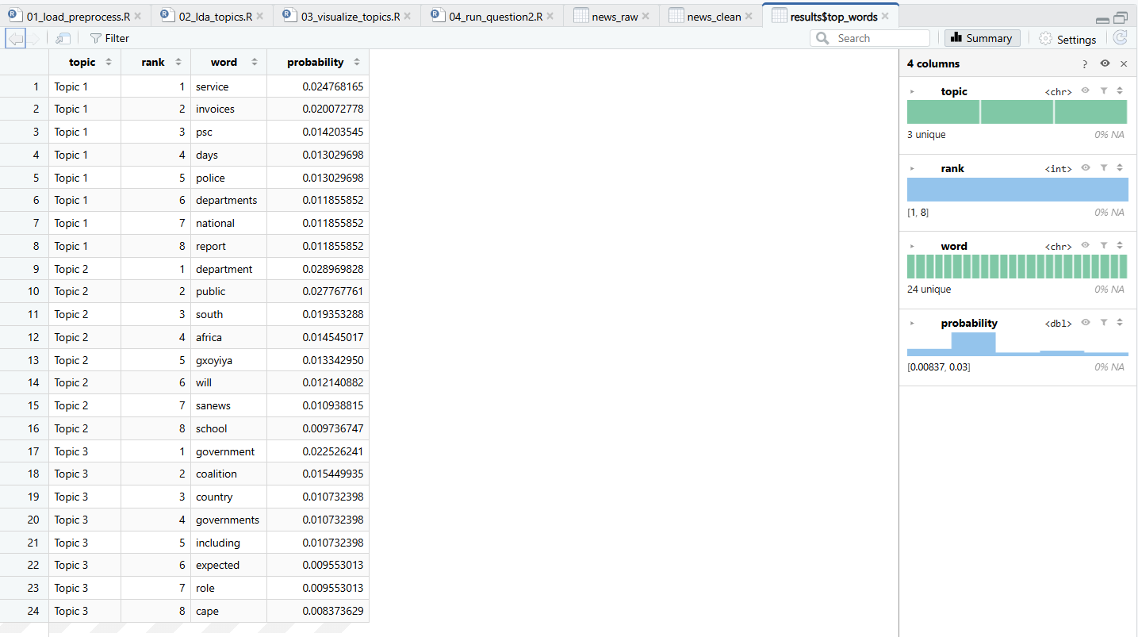
Output:
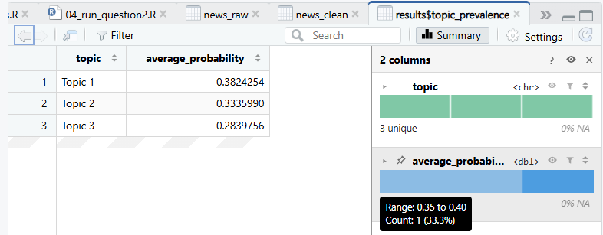
Output:
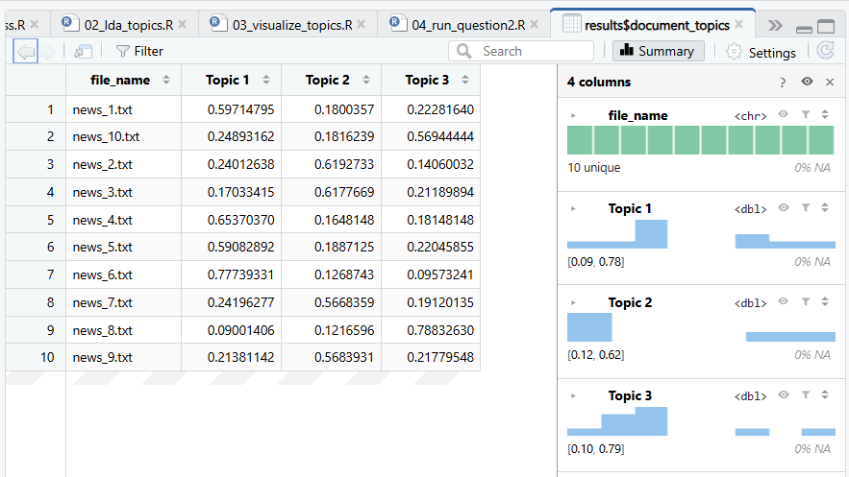

Question 2.3
I generated two visualizations using the word probabilities estimated by the LDA model. The first is a faceted horizontal bar chart showing the eight highest-probability words in each of the three topics. Its tallest bars include service for Topic 1, department for Topic 2 and government for Topic 3. The second visualization is a heatmap that compares selected keyword probabilities across all three topics, with darker blue indicating a higher estimated probability. The heatmap makes it easier to see where words are concentrated in one topic or shared across topics. Together, the two visualizations show the most important topic words and their relative distributions, with the revised bar chart showing only the relevant eight keyword labels in each topic panel.

Script: 03_visualize_topics.R
# Question 2.3 - Visualise LDA topic keywords
# 03_visualize_topics.R

create_topic_plots <- function(results) {

top_words <- results$top_words

# Method 1: Horizontal bar charts.
bar_data <- top_words

bar_data$topic_word <- paste(
bar_data$topic,
bar_data$word,
sep = "__"
)

bar_data$topic_word <- factor(
bar_data$topic_word,
levels = bar_data$topic_word[
order(bar_data$probability)
]
)

bar_plot <- ggplot2::ggplot(
bar_data,
ggplot2::aes(
x = topic_word,
y = probability,
fill = topic
)
) +
ggplot2::geom_col(show.legend = FALSE) +
ggplot2::coord_flip() +
ggplot2::facet_wrap(
~ topic,
ncol = 1,
scales = "free_y"
) +
ggplot2::scale_x_discrete(
labels = function(x) {
sub("^Topic [0-9]+__", "", x)
}
) +
ggplot2::labs(
title = "Top Words in Each LDA Topic",
x = "Keyword",
y = "Word Probability"
) +
ggplot2::theme_minimal(base_size = 12)

# Method 2: Topic-word probability heatmap.
selected_words <- unique(top_words$word)

heat_data <- results$word_distribution[
results$word_distribution$word %in%
selected_words,
]

heat_data$word <- factor(
heat_data$word,
levels = rev(selected_words)
)

heat_plot <- ggplot2::ggplot(
heat_data,
ggplot2::aes(
x = topic,
y = word,
fill = probability
)
) +
ggplot2::geom_tile(color = "white") +
ggplot2::scale_fill_gradient(
low = "white",
high = "steelblue"
) +
ggplot2::labs(
title = "Keyword Distribution Across Topics",
x = "LDA Topic",
y = "Keyword",
fill = "Probability"
) +
ggplot2::theme_minimal(base_size = 12)

# Return both visualisations.
return(list(
bar_plot = bar_plot,
heat_plot = heat_plot
))
}

Output:
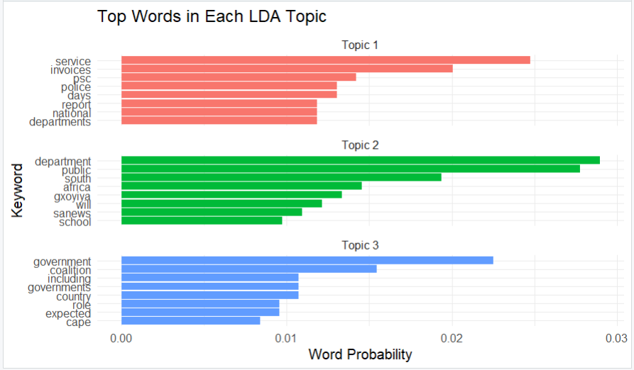
Output:
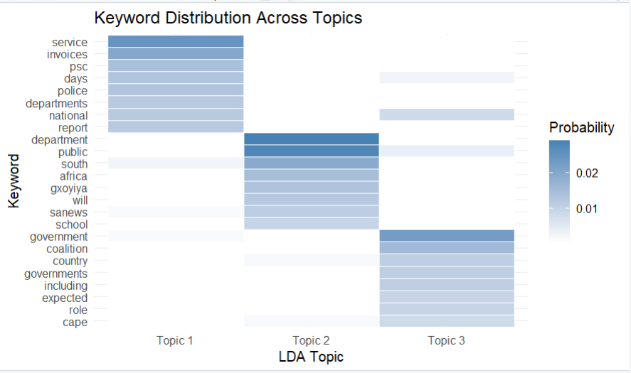

Script: 04_run_question2.R
# Question 2 - Complete topic modelling demonstration
# 04_run_question2.R

# Load the required packages.
library(tm)
library(topicmodels)
library(ggplot2)

# Load the three Question 2 scripts.
source("Question_2_Topic_Modeling/R/01_load_preprocess.R")
source("Question_2_Topic_Modeling/R/02_lda_topics.R")
source("Question_2_Topic_Modeling/R/03_visualize_topics.R")

# Configure the number of topics and words.
n_topics <- 3
top_k <- 8

# Create the output directories.
dir.create(
"Question_2_Topic_Modeling/data",
showWarnings = FALSE
)

dir.create(
"Question_2_Topic_Modeling/output",
showWarnings = FALSE
)

dir.create(
"Question_2_Topic_Modeling/plots",
showWarnings = FALSE
)

# QUESTION 2.1 - Load the news documents.
news_raw <- load_news()

# Preprocess the documents.
news_clean <- preprocess_news(news_raw)

# Save both data frames.
write.csv(
news_raw,
"Question_2_Topic_Modeling/data/news_raw.csv",
row.names = FALSE
)

write.csv(
news_clean,
"Question_2_Topic_Modeling/data/news_cleaned.csv",
row.names = FALSE
)

cat("\nQUESTION 2.1 - DATA PREPROCESSING\n")
cat("Documents loaded:", nrow(news_raw), "\n")
cat("Data frame columns:",
paste(names(news_raw), collapse = ", "), "\n")

# QUESTION 2.2 - Run the LDA model.
results <- fit_lda_model(
news_clean,
n_topics = n_topics,
top_k = top_k
)

# Save the trained model.
saveRDS(
results$model,
"Question_2_Topic_Modeling/output/lda_model.rds"
)

# Save the topic results.
write.csv(
results$top_words,
"Question_2_Topic_Modeling/output/top_words_per_topic.csv",
row.names = FALSE
)

write.csv(
results$word_distribution,
"Question_2_Topic_Modeling/output/topic_word_distribution.csv",
row.names = FALSE
)

write.csv(
results$document_topics,
"Question_2_Topic_Modeling/output/document_topic_probabilities.csv",
row.names = FALSE
)

write.csv(
results$topic_prevalence,
"Question_2_Topic_Modeling/output/topic_prevalence.csv",
row.names = FALSE
)

cat("\nQUESTION 2.2 - LDA TOPICS\n")
cat("Number of topics:", n_topics, "\n")
cat("Top words per topic:", top_k, "\n")
cat("Vocabulary size:", ncol(results$dtm), "\n\n")

cat("Top keywords and probabilities:\n")
print(results$top_words, row.names = FALSE)

cat("\nAverage topic prevalence:\n")
print(results$topic_prevalence, row.names = FALSE)

cat("\nTopic probabilities per document:\n")
print(results$document_topics, row.names = FALSE)

# QUESTION 2.3 - Create the visualisations.
plots <- create_topic_plots(results)

# Display both graphs in RStudio.
print(plots$bar_plot)
print(plots$heat_plot)

# Save the first graph.
ggplot2::ggsave(
"Question_2_Topic_Modeling/plots/01_top_words_bar.png",
plot = plots$bar_plot,
width = 10,
height = 10,
dpi = 300
)

# Save the second graph.
ggplot2::ggsave(
"Question_2_Topic_Modeling/plots/02_topic_word_heatmap.png",
plot = plots$heat_plot,
width = 10,
height = 8,
dpi = 300
)

cat("\nQUESTION 2.3 - VISUALISATIONS\n")
cat("Bar chart and heatmap saved successfully.\n")
cat("\nQuestion 2 processing completed.\n")

Output:
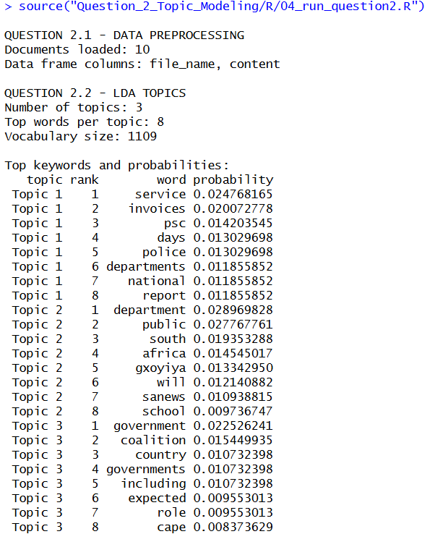
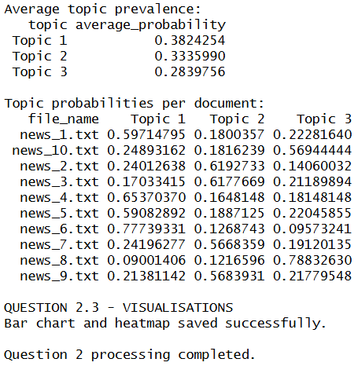

Question 3.1
I selected the NASA Science page “What Is Climate Change?” to demonstrate how an R-based WebText API can read information directly from a web link. I used the rvest and xml2 libraries to retrieve and parse the HTML and identify article paragraphs, rather than collecting navigation menus and unrelated page elements. The program takes the website URL dynamically, extracts the page title and paragraph text, removes empty or repeated paragraphs, and stores the information in an R data frame. The resulting data structure contains the source_url, page_title, paragraph_id and content columns, so each extracted paragraph can be traced back to its source. I kept the original text available for later comparison and summarisation, and the web content is used for educational research rather than bulk reproduction or redistribution.

Script: 01_scrape_webpage.R
# Question 3.1 - Web scraping using rvest and xml2
# 01_scrape_webpage.R

scrape_webpage <- function(url) {

# Check that the URL is valid.
if (!grepl("^https?://", url)) {
stop("Please enter a valid website URL.")
}

# Read the webpage HTML.
page <- tryCatch(
xml2::read_html(url),
error = function(e) {
stop("Unable to access webpage: ", e$message)
}
)

# Extract the webpage title.
page_title <- rvest::html_element(page, "h1")
page_title <- rvest::html_text2(page_title)

if (is.na(page_title) || !nzchar(page_title)) {
page_title <- "Untitled webpage"
}

# Extract paragraphs from the article.
paragraphs <- rvest::html_elements(
page, "article p"
)

# Use the main section if necessary.
if (length(paragraphs) < 4) {
paragraphs <- rvest::html_elements(
page, "main p"
)
}

if (length(paragraphs) == 0) {
stop("No article paragraphs were found.")
}

# Convert HTML paragraphs into text.
content <- rvest::html_text2(paragraphs)

# Remove excess whitespace.
content <- trimws(
gsub("\\s+", " ", content)
)

# Remove empty and very short paragraphs.
content <- content[nchar(content) >= 50]

# Remove repeated paragraphs.
content <- unique(content)

if (length(content) < 4) {
stop("Not enough article text was extracted.")
}

# Create the R data frame.
webpage_df <- data.frame(
source_url = rep(url, length(content)),
page_title = rep(page_title, length(content)),
paragraph_id = seq_along(content),
content = content,
stringsAsFactors = FALSE
)

return(webpage_df)
}

Output:
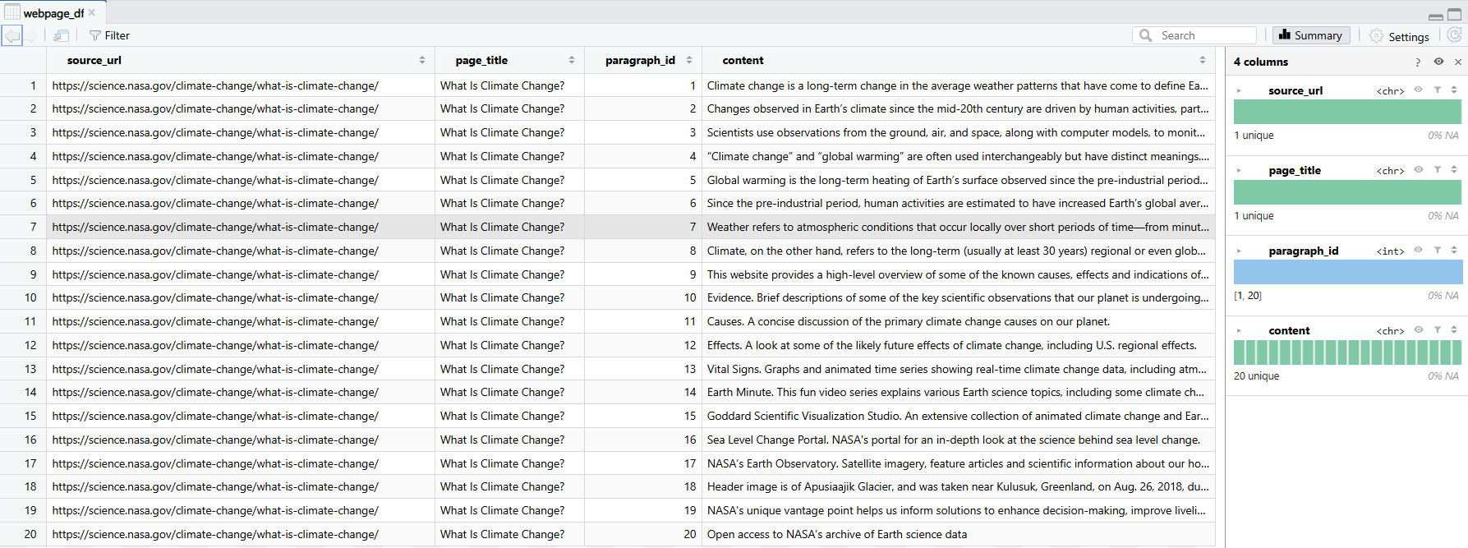

Question 3.2
I pre-processed the 20 paragraphs extracted from the NASA webpage to reduce unnecessary information and prepare the text for analysis. I converted the text to lowercase, standardised special characters, and removed URLs, punctuation, numbers and unnecessary whitespace. I also removed common English stop words, short words and selected webpage-related terms to improve the quality of the text. The original paragraph content was preserved alongside the cleaned text, allowing the results to be compared without losing important information. I also separated the content into 29 sentences and stored their original and cleaned versions in a separate data frame for summarisation. Although these techniques reduced noise, some unrelated webpage descriptions remained in the extracted content, which affected the quality of the final summaries.

Script: 02_preprocess_text.R
# Question 3.2 - Text preprocessing
# 02_preprocess_text.R

# Clean and tokenize text.
clean_words <- function(text) {

# Standardise special characters.
text <- iconv(
text,
to = "ASCII//TRANSLIT",
sub = " "
)

# Convert to lowercase.
text <- tolower(text)

# Remove URLs.
text <- gsub(
"https?://[^[:space:]]+",
" ",
text
)

# Remove numbers and punctuation.
text <- gsub("[^a-z[:space:]]", " ", text)

# Remove excess whitespace.
text <- trimws(gsub("\\s+", " ", text))

if (!nzchar(text)) {
return(character())
}

# Split into words.
words <- strsplit(text, " ", fixed = TRUE)[[1]]

# Remove short words and stop words.
words <- words[
nchar(words) >= 3 &
!words %in% tm::stopwords("en")
]

# Remove non-informative webpage words.
noise_words <- c(
"nasa", "click", "read", "more",
"image", "credit", "source", "here",
"page", "website", "learn"
)

words <- words[!words %in% noise_words]

return(words)
}

# Clean the extracted paragraphs.
preprocess_page <- function(webpage_df) {

cleaned_df <- data.frame(
paragraph_id = webpage_df$paragraph_id,
original_text = webpage_df$content,
clean_text = vapply(
webpage_df$content,
function(x) {
paste(clean_words(x), collapse = " ")
},
character(1)
),
stringsAsFactors = FALSE
)

return(cleaned_df)
}

# Divide original content into sentences.
make_sentence_data <- function(webpage_df) {

sentences <- unlist(strsplit(
webpage_df$content,
"(?<=[.!?])\\s+",
perl = TRUE
), use.names = FALSE)

# Remove extra whitespace.
sentences <- trimws(
gsub("\\s+", " ", sentences)
)

# Remove very short sentences.
sentences <- sentences[nchar(sentences) >= 35]

# Clean each sentence for analysis.
clean_sentences <- vapply(
sentences,
function(x) {
paste(clean_words(x), collapse = " ")
},
character(1)
)

# Keep sentences containing useful words.
keep <- nzchar(clean_sentences)

sentence_df <- data.frame(
sentence_id = seq_len(sum(keep)),
sentence = sentences[keep],
clean_text = clean_sentences[keep],
stringsAsFactors = FALSE
)

if (nrow(sentence_df) < 5) {
stop("Not enough sentences for summarisation.")
}

return(sentence_df)
}

Output:
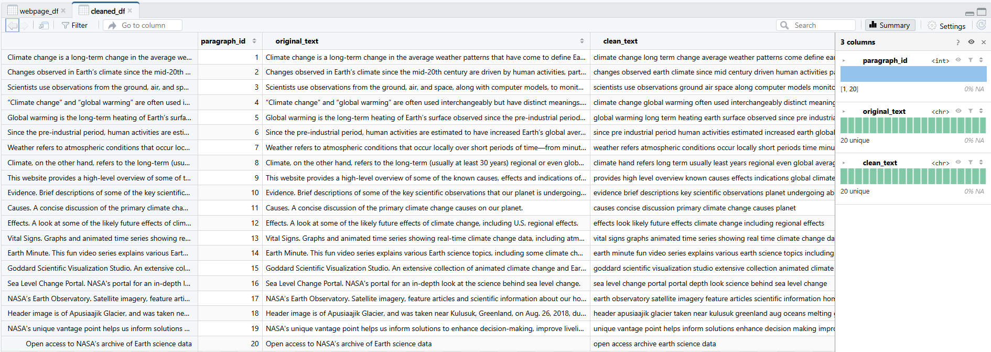
Output:
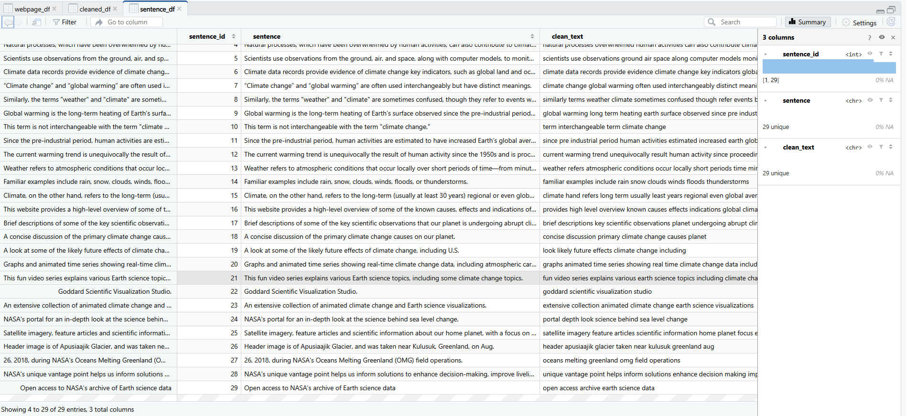

Question 3.3
I applied two extractive text summarisation techniques to the 29 sentences obtained from the NASA climate change webpage. The first technique was frequency-based summarisation, which calculated sentence importance using the average frequency of meaningful words. The second technique was TextRank, which measured sentence similarity using cosine similarity and applied the PageRank algorithm to identify important sentences. Both methods selected three sentences and arranged them in their original order to create summaries without generating new information.
The frequency-based method mainly selected sentences containing frequently repeated climate-related terms, including a statement comparing terminology and descriptions of additional NASA resources. This showed that the method identified repeated keywords but did not always select the most informative scientific content. TextRank produced a more meaningful summary by identifying the definition of climate change and scientific evidence such as increasing global temperatures, rising sea levels and melting ice. However, one TextRank sentence also described additional NASA resources, indicating that some irrelevant webpage content remained after preprocessing.
I also created two fully labelled visualisations to investigate the extracted text. The first was a horizontal bar chart displaying the twelve most frequent meaningful keywords. The most common words included climate (18 occurrences), change (16), earth (13), global (8), human (5) and temperature (5). These findings indicate that the article mainly discusses climate change, Earth's environment and global temperature changes. The second visualisation was a line graph comparing the relative sentence-importance scores calculated by the frequency-based and TextRank methods. The graph showed that the two techniques assigned different levels of importance to individual sentences. Overall, TextRank provided a more informative scientific summary, while frequency-based summarisation was more sensitive to repeated words and unrelated webpage descriptions.

Script: 03_summarize_visualize.R
# Question 3.3 - Text summarisation and visualisations
# 03_summarize_visualize.R

summarize_page <- function(
sentence_df,
n_sentences = 3) {

# Get the cleaned words in each sentence.
tokens <- strsplit(
sentence_df$clean_text,
" ",
fixed = TRUE
)

all_words <- unlist(tokens, use.names = FALSE)

# Calculate word frequencies.
word_counts <- sort(
table(all_words),
decreasing = TRUE
)

word_frequencies <- data.frame(
word = names(word_counts),
count = as.integer(word_counts),
stringsAsFactors = FALSE
)

# METHOD 1: Frequency-based summarisation.
frequency_scores <- vapply(
tokens,
function(words) {
mean(as.numeric(word_counts[words]))
},
numeric(1)
)

# METHOD 2: TextRank summarisation.

# Create a sentence-word frequency matrix.
vocabulary <- names(word_counts)

term_matrix <- t(vapply(
tokens,
function(words) {
as.numeric(table(factor(
words,
levels = vocabulary
)))
},
numeric(length(vocabulary))
))

# Calculate cosine similarity between sentences.
sentence_lengths <- sqrt(
rowSums(term_matrix^2)
)

similarity <- tcrossprod(term_matrix) /
outer(sentence_lengths, sentence_lengths)

similarity[!is.finite(similarity)] <- 0

diag(similarity) <- 0

# Build the sentence similarity graph.
graph <- igraph::graph_from_adjacency_matrix(
similarity,
mode = "undirected",
weighted = TRUE,
diag = FALSE
)

# Calculate TextRank scores using PageRank.
textrank_scores <- igraph::page_rank(
graph,
directed = FALSE
)$vector

# Select the top sentences for both methods.
n <- min(n_sentences, nrow(sentence_df))

frequency_selected <- sort(
order(frequency_scores, decreasing = TRUE)[1:n]
)

textrank_selected <- sort(
order(textrank_scores, decreasing = TRUE)[1:n]
)

# Build readable summaries.
frequency_summary <- sentence_df$sentence[
frequency_selected
]

textrank_summary <- sentence_df$sentence[
textrank_selected
]

# Store sentence importance scores.
sentence_scores <- data.frame(
sentence_id = sentence_df$sentence_id,
sentence = sentence_df$sentence,
frequency_score = frequency_scores,
textrank_score = textrank_scores,
stringsAsFactors = FALSE
)

# Return all results.
return(list(
frequency_summary = frequency_summary,
textrank_summary = textrank_summary,
word_frequencies = word_frequencies,
sentence_scores = sentence_scores
))
}

# Create two labelled visualisations.
create_summary_plots <- function(results) {

# VISUALISATION 1: Top keyword frequencies.
top_words <- head(
results$word_frequencies, 12
)

top_words$word <- factor(
top_words$word,
levels = rev(top_words$word)
)

keyword_plot <- ggplot2::ggplot(
top_words,
ggplot2::aes(x = word, y = count)
) +
ggplot2::geom_col(fill = "steelblue") +
ggplot2::coord_flip() +
ggplot2::labs(
title = "Top 12 Keywords in NASA Climate Article",
x = "Keyword",
y = "Number of Occurrences"
) +
ggplot2::theme_minimal(base_size = 12)

# VISUALISATION 2: Sentence importance scores.
scores <- results$sentence_scores

score_data <- rbind(
data.frame(
sentence_id = scores$sentence_id,
relative_score = scores$frequency_score /
max(scores$frequency_score),
method = "Frequency-Based"
),
data.frame(
sentence_id = scores$sentence_id,
relative_score = scores$textrank_score /
max(scores$textrank_score),
method = "TextRank"
)
)

importance_plot <- ggplot2::ggplot(
score_data,
ggplot2::aes(
x = sentence_id,
y = relative_score,
color = method
)
) +
ggplot2::geom_line() +
ggplot2::geom_point(size = 2) +
ggplot2::labs(
title = "Sentence Importance by Summarisation Method",
x = "Sentence Number",
y = "Relative Importance Score (0 to 1)",
color = "Method"
) +
ggplot2::theme_minimal(base_size = 12)

return(list(
keyword_plot = keyword_plot,
importance_plot = importance_plot
))
}

Output:
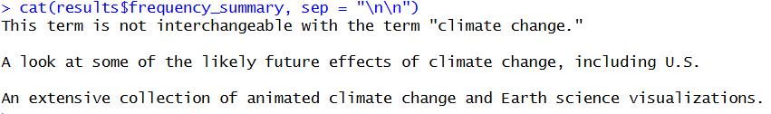
Output:
Output:
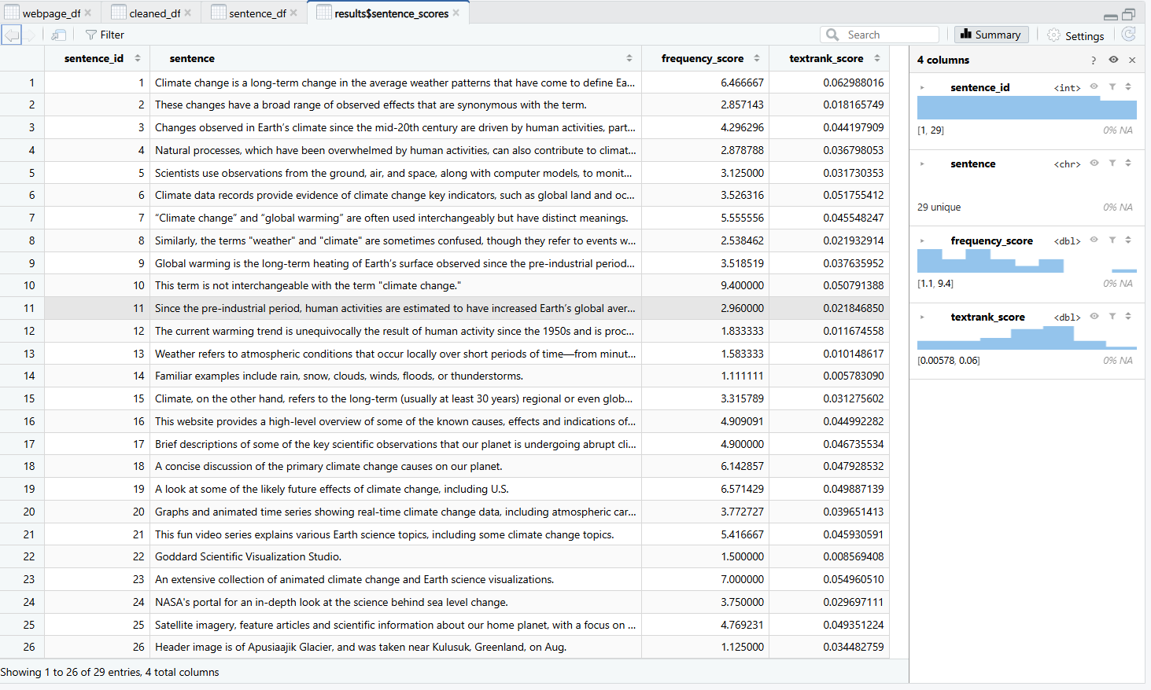
Output:
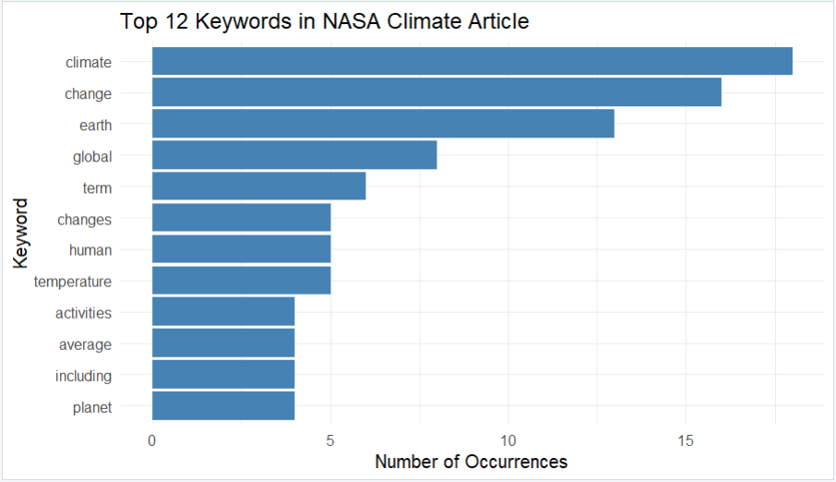
Output:
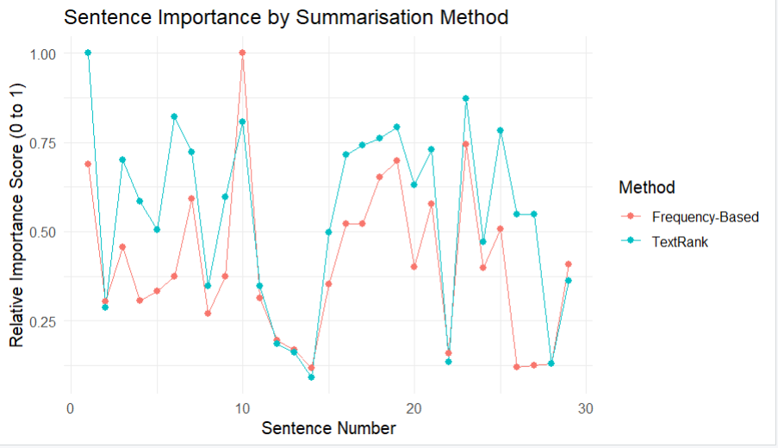

Script: 04_run_question3.R
# Question 3 - Complete WebText API demonstration
# 04_run_question3.R

# Load required libraries.
library(rvest)
library(xml2)
library(tm)
library(igraph)
library(ggplot2)

# Load the three Question 3 scripts.
source("Question_3_WebText_API/R/01_scrape_webpage.R")
source("Question_3_WebText_API/R/02_preprocess_text.R")
source("Question_3_WebText_API/R/03_summarize_visualize.R")

# Default website for the demonstration.
default_url <- paste0(
"https://science.nasa.gov/climate-change/",
"what-is-climate-change/"
)

# Ask the user for a webpage URL.
url <- utils::winDialogString(
"Enter a website URL:",
default = default_url
)

if (is.null(url) || !nzchar(trimws(url))) {
stop("A website URL is required.")
}

url <- trimws(url)

# Create output folders.
base_dir <- "Question_3_WebText_API"

dir.create(
file.path(base_dir, "data"),
recursive = TRUE,
showWarnings = FALSE
)

dir.create(
file.path(base_dir, "output"),
recursive = TRUE,
showWarnings = FALSE
)

dir.create(
file.path(base_dir, "plots"),
recursive = TRUE,
showWarnings = FALSE
)

# QUESTION 3.1 - Scrape the webpage.
cat("\nQUESTION 3.1 - WEB SCRAPING\n")

webpage_df <- scrape_webpage(url)

write.csv(
webpage_df,
file.path(base_dir, "data/webpage_raw.csv"),
row.names = FALSE
)

cat("Website:", url, "\n")
cat("Article title:", webpage_df$page_title[1], "\n")
cat("Paragraphs extracted:", nrow(webpage_df), "\n")

# QUESTION 3.2 - Preprocess the text.
cat("\nQUESTION 3.2 - TEXT PREPROCESSING\n")

cleaned_df <- preprocess_page(webpage_df)

sentence_df <- make_sentence_data(webpage_df)

write.csv(
cleaned_df,
file.path(base_dir, "data/webpage_cleaned.csv"),
row.names = FALSE
)

write.csv(
sentence_df,
file.path(base_dir, "data/sentences_cleaned.csv"),
row.names = FALSE
)

cat("Cleaned paragraphs:", nrow(cleaned_df), "\n")
cat("Sentences for analysis:", nrow(sentence_df), "\n")

# QUESTION 3.3 - Generate summaries.
cat("\nQUESTION 3.3 - TEXT SUMMARISATION\n")

results <- summarize_page(
sentence_df,
n_sentences = 3
)

cat("\nMETHOD 1 - FREQUENCY-BASED SUMMARY:\n")
cat(
paste(results$frequency_summary, collapse = " "),
"\n"
)

cat("\nMETHOD 2 - TEXTRANK SUMMARY:\n")
cat(
paste(results$textrank_summary, collapse = " "),
"\n"
)

# Save both summaries.
writeLines(
results$frequency_summary,
file.path(base_dir, "output/summary_frequency.txt")
)

writeLines(
results$textrank_summary,
file.path(base_dir, "output/summary_textrank.txt")
)

# Save scores and word frequencies.
write.csv(
results$sentence_scores,
file.path(base_dir, "output/sentence_scores.csv"),
row.names = FALSE
)

write.csv(
results$word_frequencies,
file.path(base_dir, "output/word_frequencies.csv"),
row.names = FALSE
)

cat("\nTop 12 keywords:\n")
print(head(results$word_frequencies, 12))

# Create both visualisations.
plots <- create_summary_plots(results)

# Display the graphs in RStudio.
print(plots$keyword_plot)
print(plots$importance_plot)

# Save Graph 1.
ggplot2::ggsave(
file.path(base_dir, "plots/01_top_keywords.png"),
plot = plots$keyword_plot,
width = 10,
height = 6,
dpi = 300
)

# Save Graph 2.
ggplot2::ggsave(
file.path(base_dir, "plots/02_sentence_importance.png"),
plot = plots$importance_plot,
width = 10,
height = 6,
dpi = 300
)

cat("\nBoth graphs saved successfully.\n")
cat("\nQuestion 3 processing completed.\n")

Output:
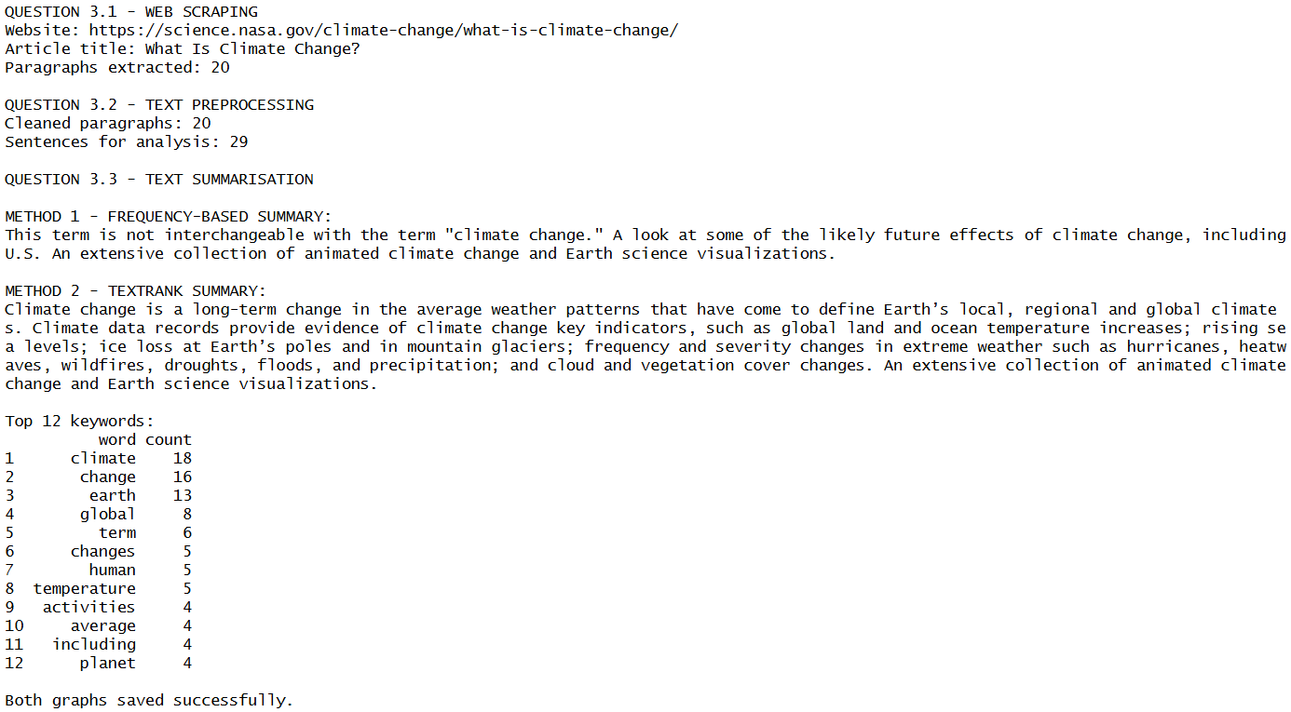

Question 4.1
For my ETL use case, I selected Books to Scrape, an educational website designed for practising web scraping. I used the rvest and xml2 libraries in R to extract 40 book records from two publicly accessible catalogue pages, exceeding the minimum requirement of 20 records. The extracted information was stored in an R data frame containing displayed book titles, complete titles, original price values, rating classes, availability information, category values and source URLs. The raw data contained inconsistent formatting, including pound currency symbols, ratings represented as words, shortened book titles and unnecessary whitespace in availability information. The original price and rating fields contained numerical information represented as text, which required conversion into numerical data during the transformation stage. Category information was not available on the listing pages and was therefore recorded as missing rather than assigning incorrect values. This provided a suitable example of unstructured web data requiring cleaning, regular expression analysis and transformation before being stored in a relational database. Since Books to Scrape uses demonstration prices and ratings, the collected information was used to demonstrate ETL techniques rather than represent actual retail market conditions.

Script: 01_scrape_books.R
# Question 4.1 - Scrape unstructured book listings
# 01_scrape_books.R

scrape_books <- function(pages = 1:2) {
all_pages <- list()

for (page_number in pages) {
url <- paste0(
"https://books.toscrape.com/catalogue/page-",
page_number, ".html"
)

page <- xml2::read_html(url)
cards <- rvest::html_elements(page, "article.product_pod")

if (length(cards) == 0) {
stop("No books found on: ", url)
}

records <- lapply(cards, function(card) {
link <- rvest::html_element(card, "h3 a")
price <- rvest::html_element(card, ".price_color")
rating <- rvest::html_element(card, "p.star-rating")
availability <- rvest::html_element(card, ".availability")

data.frame(
title_display = rvest::html_text2(link),
title_full = rvest::html_attr(link, "title"),
price_raw = rvest::html_text(price, trim = FALSE),
rating_raw = rvest::html_attr(rating, "class"),
availability_raw = rvest::html_text(
availability, trim = FALSE
),
category_raw = NA_character_,
source_url = url,
stringsAsFactors = FALSE
)
})

all_pages[[length(all_pages) + 1]] <- do.call(rbind, records)
if (page_number != tail(pages, 1)) Sys.sleep(1)
}

books_raw <- do.call(rbind, all_pages)
rownames(books_raw) <- NULL

if (nrow(books_raw) < 20) {
stop("Fewer than 20 records were scraped.")
}

return(books_raw)
}

Output:
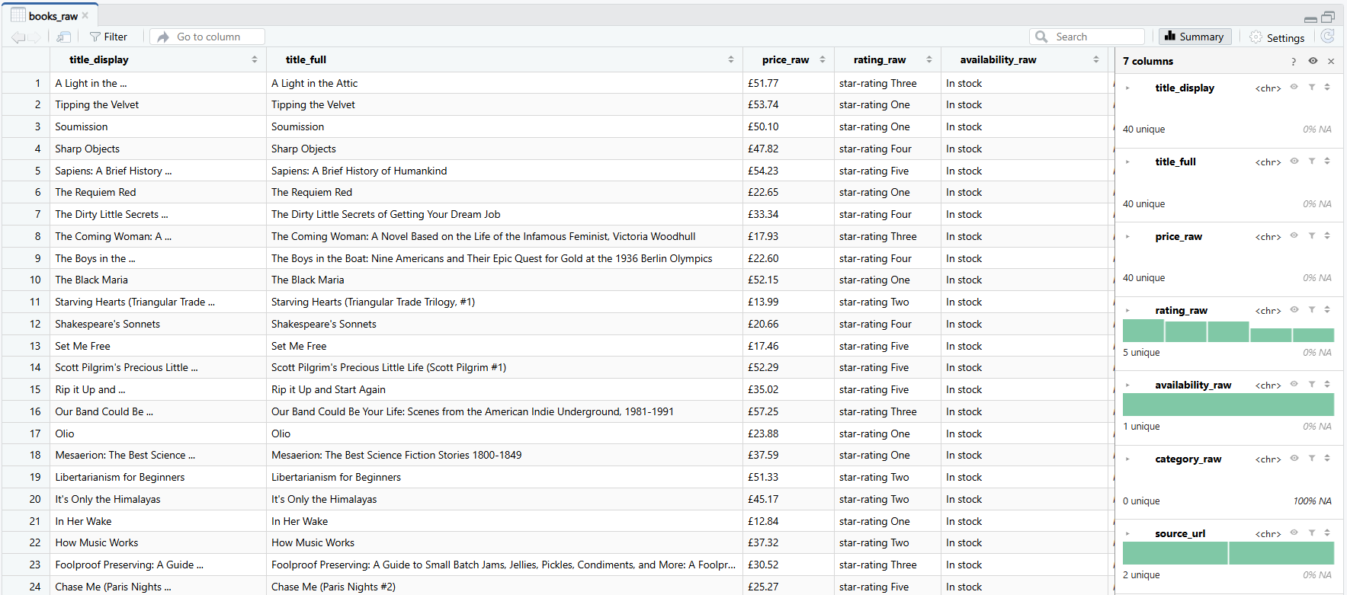
Output:

Question 4.2
I cleaned and transformed the 40 extracted book records into a structured dataset suitable for analysis and PostgreSQL storage. The cleaning process removed unnecessary whitespace, retained complete book titles and used regular expressions to extract numerical prices from the original currency strings. I also converted the written rating categories into integer values between 1 and 5, standardised availability information and classified books into Budget, Mid-range and Premium price bands. All 40 records were retained, and the cleaned dataset contained no missing price or rating values. Although the program included median imputation for missing numerical values, no price or rating imputation was required because these fields were complete. The 40 missing category values were instead labelled "Not provided" to prevent incorrect category assignments. Finally, I exported the cleaned dataset as books_cleaned.csv, providing a consistent CSV file suitable for further analysis and PostgreSQL import.

Script: 02_clean_books.R
# Question 4.2 - Clean, denoise and impute book records
# 02_clean_books.R

clean_books <- function(books_raw) {

# Extract a numeric price with a regular expression.
extract_price <- function(x) {
if (is.na(x)) return(NA_real_)
match <- regexpr("[0-9]+\\.[0-9]{2}", x)
if (match[1] == -1) return(NA_real_)
as.numeric(regmatches(x, match))
}

# Extract One-Five from the HTML rating class.
extract_rating <- function(x) {
if (is.na(x)) return(NA_integer_)
found <- regexpr("One|Two|Three|Four|Five", x)
if (found[1] == -1) return(NA_integer_)
base::match(regmatches(x, found),
c("One", "Two", "Three", "Four", "Five"))
}

# Prefer the complete title instead of the shortened label.
title <- ifelse(
is.na(books_raw$title_full) |
!nzchar(trimws(books_raw$title_full)),
books_raw$title_display,
books_raw$title_full
)
title <- trimws(gsub("[[:space:]]+", " ", title))
title[!nzchar(title)] <- "Unknown title"

price <- vapply(books_raw$price_raw, extract_price, numeric(1))
rating <- vapply(books_raw$rating_raw, extract_rating, integer(1))

price_imputed <- is.na(price)
rating_imputed <- is.na(rating)

# Use the observed median if any numerical values are missing.
if (all(price_imputed) || all(rating_imputed)) {
stop("Not enough valid price or rating values to impute.")
}
price[price_imputed] <- median(price, na.rm = TRUE)
rating[rating_imputed] <- as.integer(
round(median(rating, na.rm = TRUE))
)

availability <- ifelse(
grepl("in[[:space:]]+stock", books_raw$availability_raw,
ignore.case = TRUE),
"In stock", "Unknown"
)

# The listing pages do not provide a book category.
category <- ifelse(
is.na(books_raw$category_raw) |
!nzchar(trimws(books_raw$category_raw)),
"Not provided", trimws(books_raw$category_raw)
)

price_band <- as.character(cut(
price,
breaks = c(-Inf, 20, 40, Inf),
labels = c("Budget", "Mid-range", "Premium")
))

books_cleaned <- data.frame(
book_id = seq_along(title),
title = title,
price_gbp = round(price, 2),
rating = rating,
availability = availability,
category = category,
price_band = price_band,
price_imputed = price_imputed,
rating_imputed = rating_imputed,
source_url = books_raw$source_url,
stringsAsFactors = FALSE
)

return(books_cleaned)
}

Output:
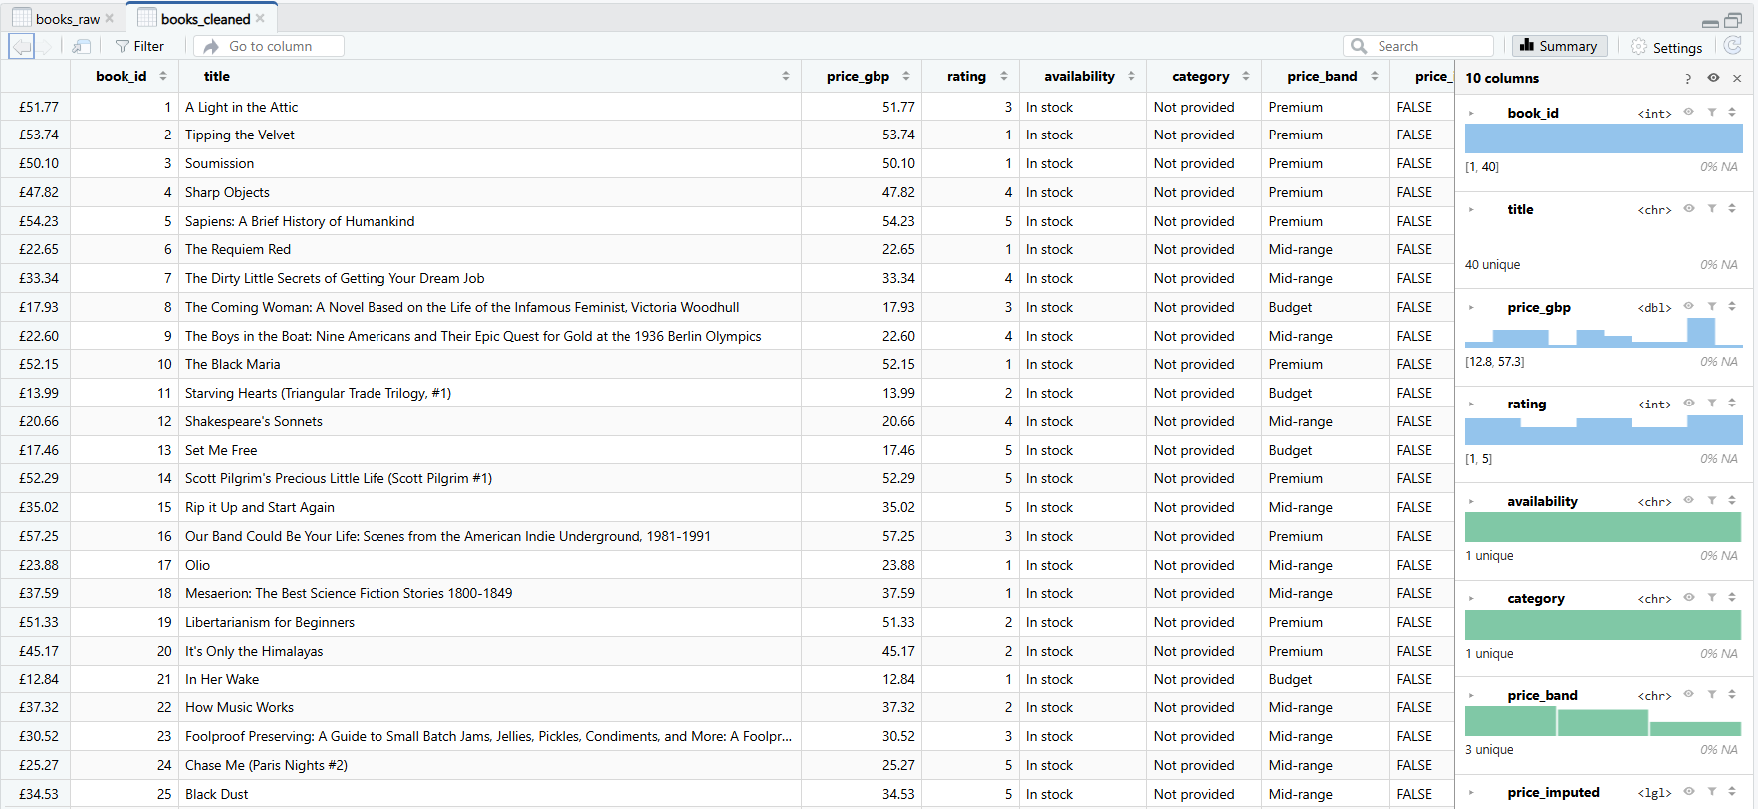
Output:
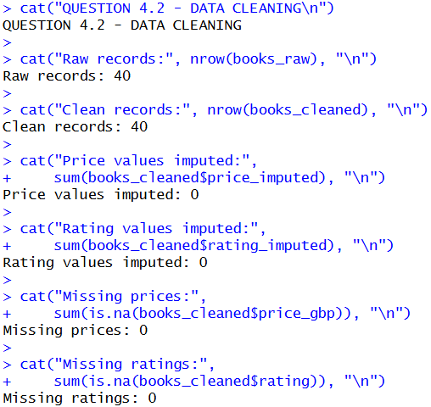

Question 4.3
I imported the cleaned dataset containing 40 book records into a PostgreSQL database named itbda_project2 using the DBI and RPostgres libraries. The records were stored in a relational table named books_etl, containing the cleaned book titles, numerical prices, ratings, availability information and price categories. I used pgAdmin to execute two SQL analytical investigations to demonstrate how structured data can support analytical reporting.
The first SQL investigation compared book prices across the five rating categories using record counts and average prices. The results showed that books rated 3 stars had the highest average price of £39.12, while books rated 5 stars had the lowest average price of £31.65. The other average prices were £34.39 for 1-star books, £33.24 for 2-star books and £36.80 for 4-star books. These findings suggest that higher book ratings were not consistently associated with higher prices in the collected dataset.
The second SQL investigation compared the Budget, Mid-range and Premium price categories. The results showed that the Mid-range category contained the most books, with 17 records and an average price of £29.68. The Budget category contained 8 books with an average price of £16.68, while the Premium category contained 15 books with an average price of £50.69. The average ratings were very similar across the categories, ranging from 3.00 for Budget to 3.07 for Premium. This indicates that the higher-priced books did not consistently receive better ratings within this sample. Overall, the two investigations demonstrate how PostgreSQL can organise cleaned web data and generate useful analytical reports using SQL queries. However, because the website uses demonstration prices and ratings, these findings should not be interpreted as genuine consumer market trends.

Script: 03_load_postgres.R
# Question 4.3 - Load the cleaned CSV into PostgreSQL
# 03_load_postgres.R

load_books_postgres <- function(
csv_path = "Question_4_ETL_PostgreSQL/data/books_cleaned.csv",
database = "itbda_project2"
) {
books <- read.csv(csv_path, stringsAsFactors = FALSE)

# RStudio asks securely for the existing postgres-user password.
password <- rstudioapi::askForPassword("PostgreSQL password")
if (!nzchar(password)) stop("A database password is required.")

con <- DBI::dbConnect(
RPostgres::Postgres(),
dbname = database,
host = "localhost",
port = 5432,
user = "postgres",
password = password
)
on.exit(DBI::dbDisconnect(con), add = TRUE)
rm(password)

# This replaces only the project table, never the database.
DBI::dbWriteTable(
con, "books_etl", books,
overwrite = TRUE, row.names = FALSE
)

cat("Records loaded into PostgreSQL:",
DBI::dbGetQuery(con,
"SELECT COUNT(*) AS n FROM books_etl")$n, "\n")

query1 <- paste(
"SELECT rating, COUNT(*) AS books,",
"ROUND(AVG(price_gbp)::numeric, 2) AS avg_price_gbp",
"FROM books_etl GROUP BY rating ORDER BY rating"
)
query2 <- paste(
"SELECT price_band, COUNT(*) AS books,",
"ROUND(AVG(rating)::numeric, 2) AS avg_rating,",
"ROUND(AVG(price_gbp)::numeric, 2) AS avg_price_gbp",
"FROM books_etl GROUP BY price_band ORDER BY MIN(price_gbp)"
)

result1 <- DBI::dbGetQuery(con, query1)
result2 <- DBI::dbGetQuery(con, query2)

write.csv(result1,
"Question_4_ETL_PostgreSQL/output/query_1_results.csv",
row.names = FALSE)
write.csv(result2,
"Question_4_ETL_PostgreSQL/output/query_2_results.csv",
row.names = FALSE)

cat("\nQUERY 1 - AVERAGE PRICE BY RATING\n")
print(result1)
cat("\nQUERY 2 - PRICE BAND ANALYSIS\n")
print(result2)

invisible(list(query1 = result1, query2 = result2))
}

SQL: 01_average_price_by_rating.sql
-- Question 4.3 - SQL investigation 1: price by rating
SELECT
rating,
COUNT(*) AS books,
ROUND(AVG(price_gbp)::numeric, 2) AS avg_price_gbp,
MIN(price_gbp) AS min_price_gbp,
MAX(price_gbp) AS max_price_gbp
FROM public.books_etl
GROUP BY rating
ORDER BY rating;
Output:
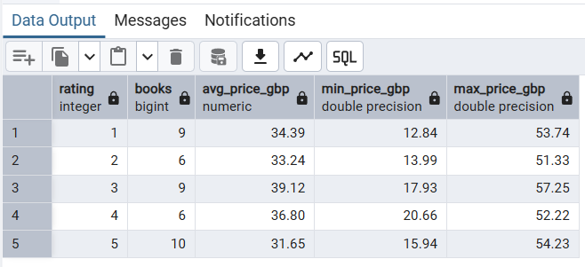

SQL: 02_price_band_analysis.sql
-- Question 4.3 - SQL investigation 2: compare price bands
SELECT
price_band,
COUNT(*) AS books,
ROUND(AVG(rating)::numeric, 2) AS avg_rating,
ROUND(AVG(price_gbp)::numeric, 2) AS avg_price_gbp
FROM public.books_etl
GROUP BY price_band
ORDER BY MIN(price_gbp);
Output:
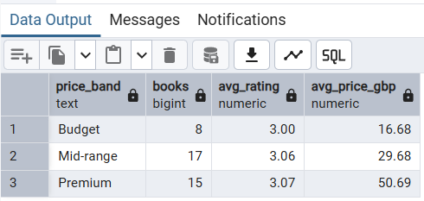

Script: 04_run_question4.R
# Question 4 - Complete R ETL demonstration
# 04_run_question4.R

library(rvest)
library(xml2)

source("Question_4_ETL_PostgreSQL/R/01_scrape_books.R")
source("Question_4_ETL_PostgreSQL/R/02_clean_books.R")
source("Question_4_ETL_PostgreSQL/R/03_load_postgres.R")

base_dir <- "Question_4_ETL_PostgreSQL"
dir.create(file.path(base_dir, "data"), showWarnings = FALSE)
dir.create(file.path(base_dir, "output"), showWarnings = FALSE)

# QUESTION 4.1 - Extract at least 20 raw records.
books_raw <- scrape_books(pages = 1:2)
write.csv(books_raw, file.path(base_dir, "data/books_raw.csv"),
row.names = FALSE, fileEncoding = "UTF-8")
cat("QUESTION 4.1 - BOOKS SCRAPED:", nrow(books_raw), "\n")

# QUESTION 4.2 - Transform and export the clean dataset.
books_cleaned <- clean_books(books_raw)
write.csv(books_cleaned,
file.path(base_dir, "data/books_cleaned.csv"),
row.names = FALSE, fileEncoding = "UTF-8")
cat("QUESTION 4.2 - CLEAN RECORDS:", nrow(books_cleaned), "\n")
cat("Price values imputed:", sum(books_cleaned$price_imputed), "\n")
cat("Rating values imputed:", sum(books_cleaned$rating_imputed), "\n")
print(head(books_cleaned, 5))

# QUESTION 4.3 - Import into PostgreSQL and run two SQL queries.
cat("\nQUESTION 4.3 - POSTGRESQL\n")
load_books_postgres()
cat("\nQuestion 4.1-4.3 completed.\n")

Output:
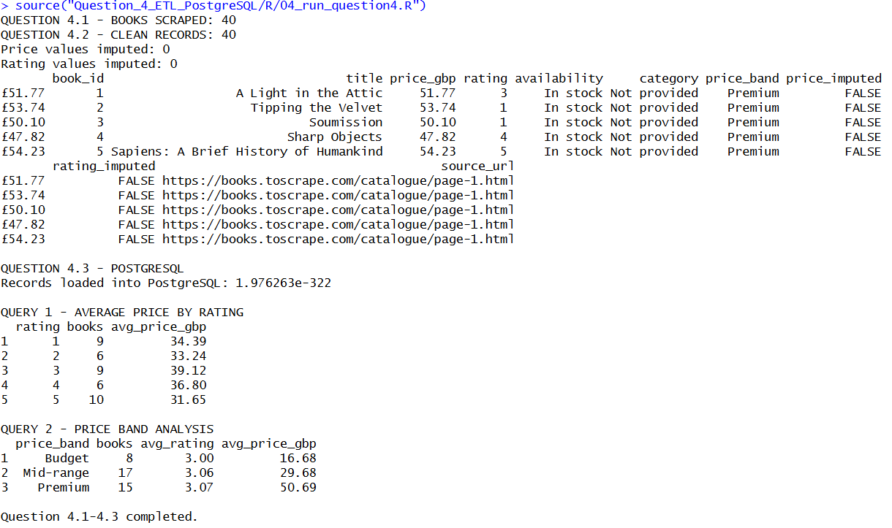

Question 4.4
Github repository link: https://github.com/EDUV4818544/ITBDA4-14-Project-2-Online-Campus-EDUV4818544
List of References:
1. Apache Software Foundation (2026) Apache Hadoop MapReduce Streaming. Available at: https://hadoop.apache.org/docs/current/hadoop-streaming/HadoopStreaming.html (Accessed: 4 November 2026).
2. Blei, D.M., Ng, A.Y. and Jordan, M.I. (2003) 'Latent Dirichlet allocation', Journal of Machine Learning Research, 3, pp. 993–1022. Available at: https://www.jmlr.org/papers/v3/blei03a.html (Accessed: 4 November 2026).
3. Books to Scrape (n.d.) Books to Scrape: A web scraping sandbox. Available at: https://books.toscrape.com/ (Accessed: 4 November 2026).
4. Csárdi, G. and Nepusz, T. (2006) 'The igraph software package for complex network research', InterJournal, Complex Systems, 1695. Available at: https://igraph.org/ (Accessed: 4 November 2026).
5. Dean, J. and Ghemawat, S. (2008) 'MapReduce: Simplified data processing on large clusters', Communications of the ACM, 51(1), pp. 107–113. Available at: https://doi.org/10.1145/1327452.1327492 (Accessed: 4 November 2026).
6. Feinerer, I., Hornik, K. and Meyer, D. (2008) 'Text mining infrastructure in R', Journal of Statistical Software, 25(5), pp. 1–54. Available at: https://doi.org/10.18637/jss.v025.i05 (Accessed: 4 November 2026).
7. GitHub (n.d.) Creating a new repository. GitHub Docs. Available at: https://docs.github.com/en/repositories/creating-and-managing-repositories/creating-a-new-repository (Accessed: 4 November 2026).
8. Grün, B. and Hornik, K. (2011) 'topicmodels: An R package for fitting topic models', Journal of Statistical Software, 40(13), pp. 1–30. Available at: https://doi.org/10.18637/jss.v040.i13 (Accessed: 4 November 2026).
9. Koster, M., Illyes, G., Zeller, H. and Sassman, L. (2022) Robots Exclusion Protocol. RFC 9309. Internet Engineering Task Force. Available at: https://www.rfc-editor.org/rfc/rfc9309.html (Accessed: 4 November 2026).
10. Little, R.J.A. and Rubin, D.B. (2019) Statistical Analysis with Missing Data. 3rd edn. Hoboken, NJ: John Wiley & Sons. Available at: https://doi.org/10.1002/9781119482260 (Accessed: 4 November 2026).
11. Mihalcea, R. and Tarau, P. (2004) 'TextRank: Bringing order into text', Proceedings of the 2004 Conference on Empirical Methods in Natural Language Processing, pp. 404–411. Barcelona: Association for Computational Linguistics. Available at: https://aclanthology.org/W04-3252/ (Accessed: 4 November 2026).
12. National Aeronautics and Space Administration (NASA) (n.d.) What Is Climate Change? NASA Science. Available at: https://science.nasa.gov/climate-change/what-is-climate-change/ (Accessed: 4 November 2026).
13. Page, L., Brin, S., Motwani, R. and Winograd, T. (1999) The PageRank Citation Ranking: Bringing Order to the Web. Technical Report. Stanford University. Available at: https://philpapers.org/rec/PAGTPC (Accessed: 4 November 2026).
14. pgAdmin Development Team (n.d.) Query Tool. pgAdmin 4 Documentation. Available at: https://www.pgadmin.org/docs/pgadmin4/latest/query_tool.html (Accessed: 4 November 2026).
15. PostgreSQL Global Development Group (n.d.) PostgreSQL 18 Documentation: SELECT. Available at: https://www.postgresql.org/docs/18/sql-select.html (Accessed: 4 November 2026).
16. R Core Team (2026) R: A Language and Environment for Statistical Computing. Vienna: R Foundation for Statistical Computing. Available at: https://www.R-project.org/ (Accessed: 4 November 2026).
17. R Special Interest Group on Databases (R-SIG-DB), Wickham, H. and Müller, K. (2026) DBI: R Database Interface. R package version 1.3.0. Available at: https://dbi.r-dbi.org/ (Accessed: 4 November 2026).
18. Silge, J. and Robinson, D. (2017) Text Mining with R: A Tidy Approach. Sebastopol, CA: O'Reilly Media. Available at: https://www.tidytextmining.com/ (Accessed: 4 November 2026).
19. Wickham, H. (2014) 'Tidy data', Journal of Statistical Software, 59(10), pp. 1–23. Available at: https://doi.org/10.18637/jss.v059.i10 (Accessed: 4 November 2026).
20. Wickham, H. (2016) ggplot2: Elegant Graphics for Data Analysis. 2nd edn. Cham: Springer. Available at: https://doi.org/10.1007/978-3-319-24277-4 (Accessed: 4 November 2026).
21. Wickham, H. (2025) rvest: Easily Harvest (Scrape) Web Pages. R package version 1.0.5. Available at: https://rvest.tidyverse.org/ (Accessed: 4 November 2026).
22. Wickham, H. and Grolemund, G. (2017) R for Data Science: Import, Tidy, Transform, Visualize, and Model Data. Sebastopol, CA: O'Reilly Media. Available at: https://r4ds.had.co.nz/ (Accessed: 4 November 2026).
23. Wickham, H., Hester, J. and Ooms, J. (2026) xml2: Parse XML. R package version 1.6.0. Available at: https://xml2.r-lib.org/ (Accessed: 4 November 2026).
24. Wickham, H., Ooms, J. and Müller, K. (2026) RPostgres: C++ Interface to PostgreSQL. R package version 1.4.10. Available at: https://rpostgres.r-dbi.org/ (Accessed: 4 November 2026).

